To: Professor Yuce

Applied Mathematics

New York City College of Technology

From: Brian Holliday

Applied Mathematics

New York City College of Technology

Subject: Least squares spline fitting on fish growth data

Figure:

Figure 1 Linear Vs Quadratic

Figure 2 Cubic vs Spline 1 vs Spline 2

Date: 2/20/20

Summary:

In this lab we discussed spline regression. We use spline regression when none of our other regression models fit the data. Spline regression used a piecewise function based on the value in which the shape of the data changes. We could see how well spline fit the graph in figure 2. Spline 1 fits better than spline 2 because spline 2 is over fit with an extra variable

Linear vs Quadratic

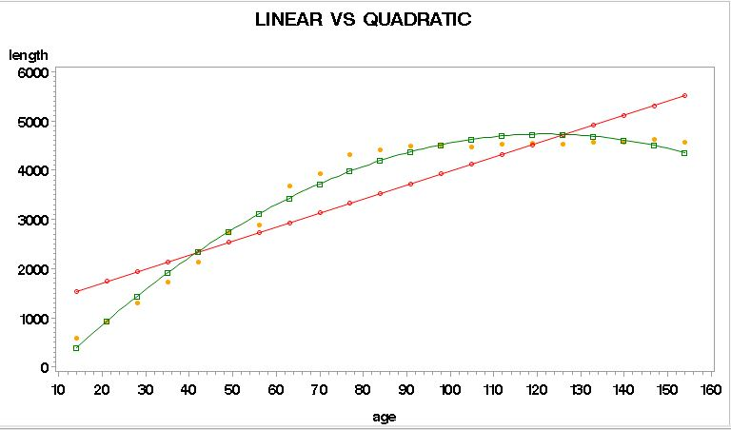

Cubic vs Spline1 vs Spline2

